|  |  |
| --- | --- |
| **Declaration** |  |
| Questions in this exercise are intentionally complex and could be convoluted or confusing. This is by design and to si mulate real life situations where customers seldom give crystal clear requirements and ask unambiguou s questions. | |
| I have read the above statement and agree to these conditions | |
| I AGREE |  |
| <Enter your name above this line to indicate that you are in agreement> |

|  |  |
| --- | --- |
| **Instructions** |  |
| Every screenshot requested in this workbook is compulsory and carries 1 marks | |
| Your AWS account ID must be clearly visible in every screenshot using the AWS console; missing id or using someone else's id is not permitted. Such cases will be considered as plagiarism and severe penalty will be imposed. | |
| All screenshots must be in the order mentioned under "Expected Screenshots" for every step | |
| DO NOT WAIT UNTIL THE LAST MINUTE. The program office will not extend the project submission deadline under any circumstances. | |
| The file should be renamed in the format BATCH_FIRSTNAME_LASTNAME_PROJECT1. For example: PGPCCMAY18_VIJAY_DWIVEDI_PROJECT1.pdf | |

|  |  |
| --- | --- |
| **Resource Clean Up** |  |
| Cloud is always pay per use model and all resources/services that we consume are chargeable.  Cleaning up when you’ve completed your lab or project is always necessary. This is true whether you’re doing a lab or implementing a project at your workplace. | |
| After completing the lab, make sure to delete each resource created in reverse chronological order.  Each AWS Academy session lasts for 4 hours by default, although you can extend a session to run longer by pressing the start button to reset your session timer. At the end of each session, any resources you created in the account will be preserved. Some AWS resources, such as EC2 instances, may be automatically shut down, while other resources, such as RDS instances will be left running. | |

**Architecture diagram**

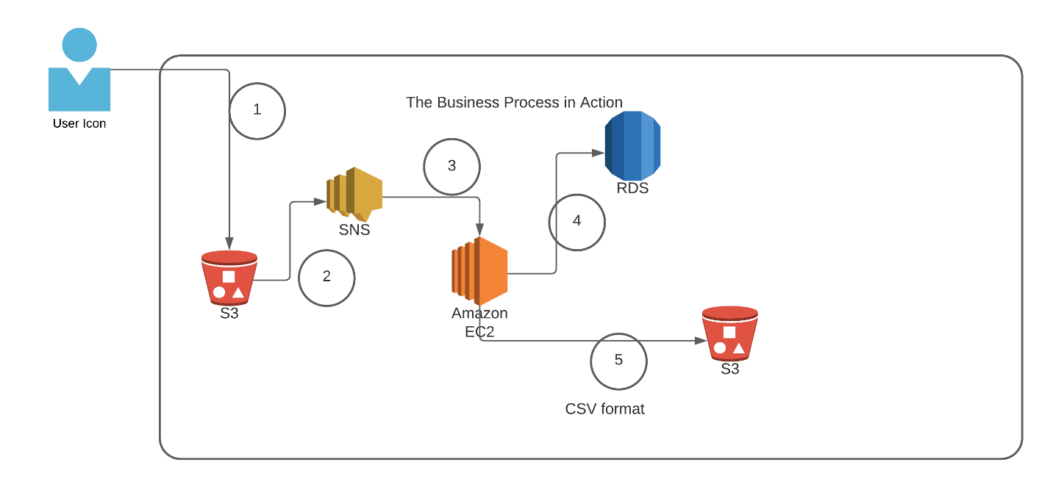

|  |  |
| --- | --- |
| **Architecture Implementation** | |
| 1 | The customer uploads the invoice data to S3 bucket in a text format as per their guidelines and policies. This bucket will have a policy to auto delete any content that is more than 1 day old (24 hours). |
| 2 | An event will trigger in the bucket that will place a message in SNS topic |
| 3 | A custom program running in EC2 will subscribe to the SNS topic and get the message placed by S3 event |
| 4 | The program will use S3 API to read from the bucket, parse the content of the file and create a CSV record and save the details in an RDS database |
| 5 | The program will use S3 API to write CSV record to destination S3 bucket as new S3 object. |
| Note | The custom program codebase and sample invoice have been shared along with this workbook on the LMS. |

**Step 1: SNS and S3 topic creation**

|  |  |
| --- | --- |
| Step number | a |
| Step name | Creation of Source and target buckets |
| Instructions | 1. Navigate to S3 using the Services button at the top of the screen 2. Select "Create Bucket" 3. Enter a source bucket name and use the default options for the rest of the fields 4. Click on "Create Bucket' 5. Repeat the above steps to create a target bucket |
| Expected screenshots | 1) Screen showing created S3 source and target buckets |

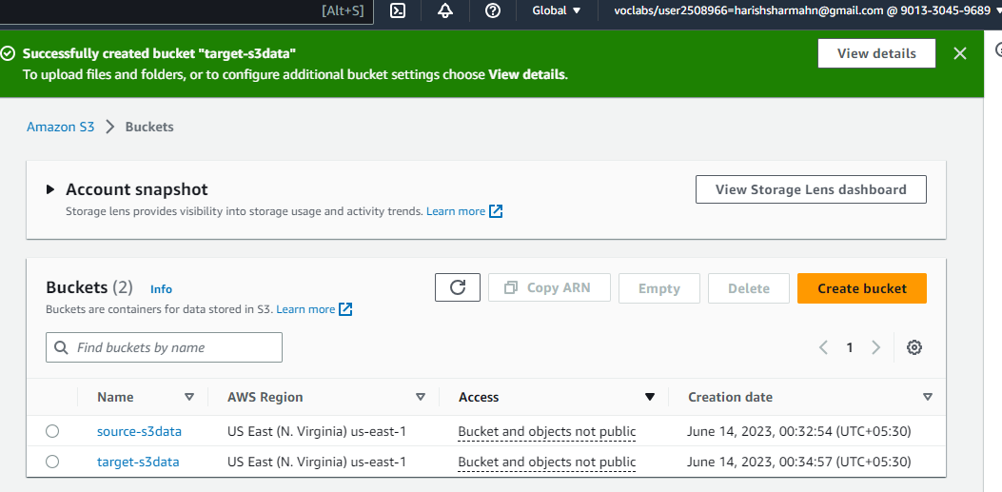

|  |  |
| --- | --- |
| Step number | b |
| Step name | Creation of SNS subscription |
| Instructions | 1. Navigate to SNS -> Topics 2. Click on "Create Topic" 3. Enter the following fields   Name : S3toEC2Topic  The other options can be ignored for now   1. Click on Create Topic |
| Expected screenshots | 1) Creation of SNS topic |

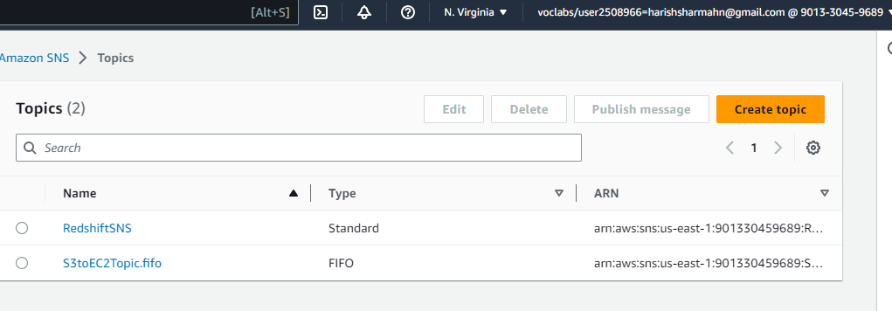

Step

number

c

Step

name

Modification

of

SNS

Access

Policy

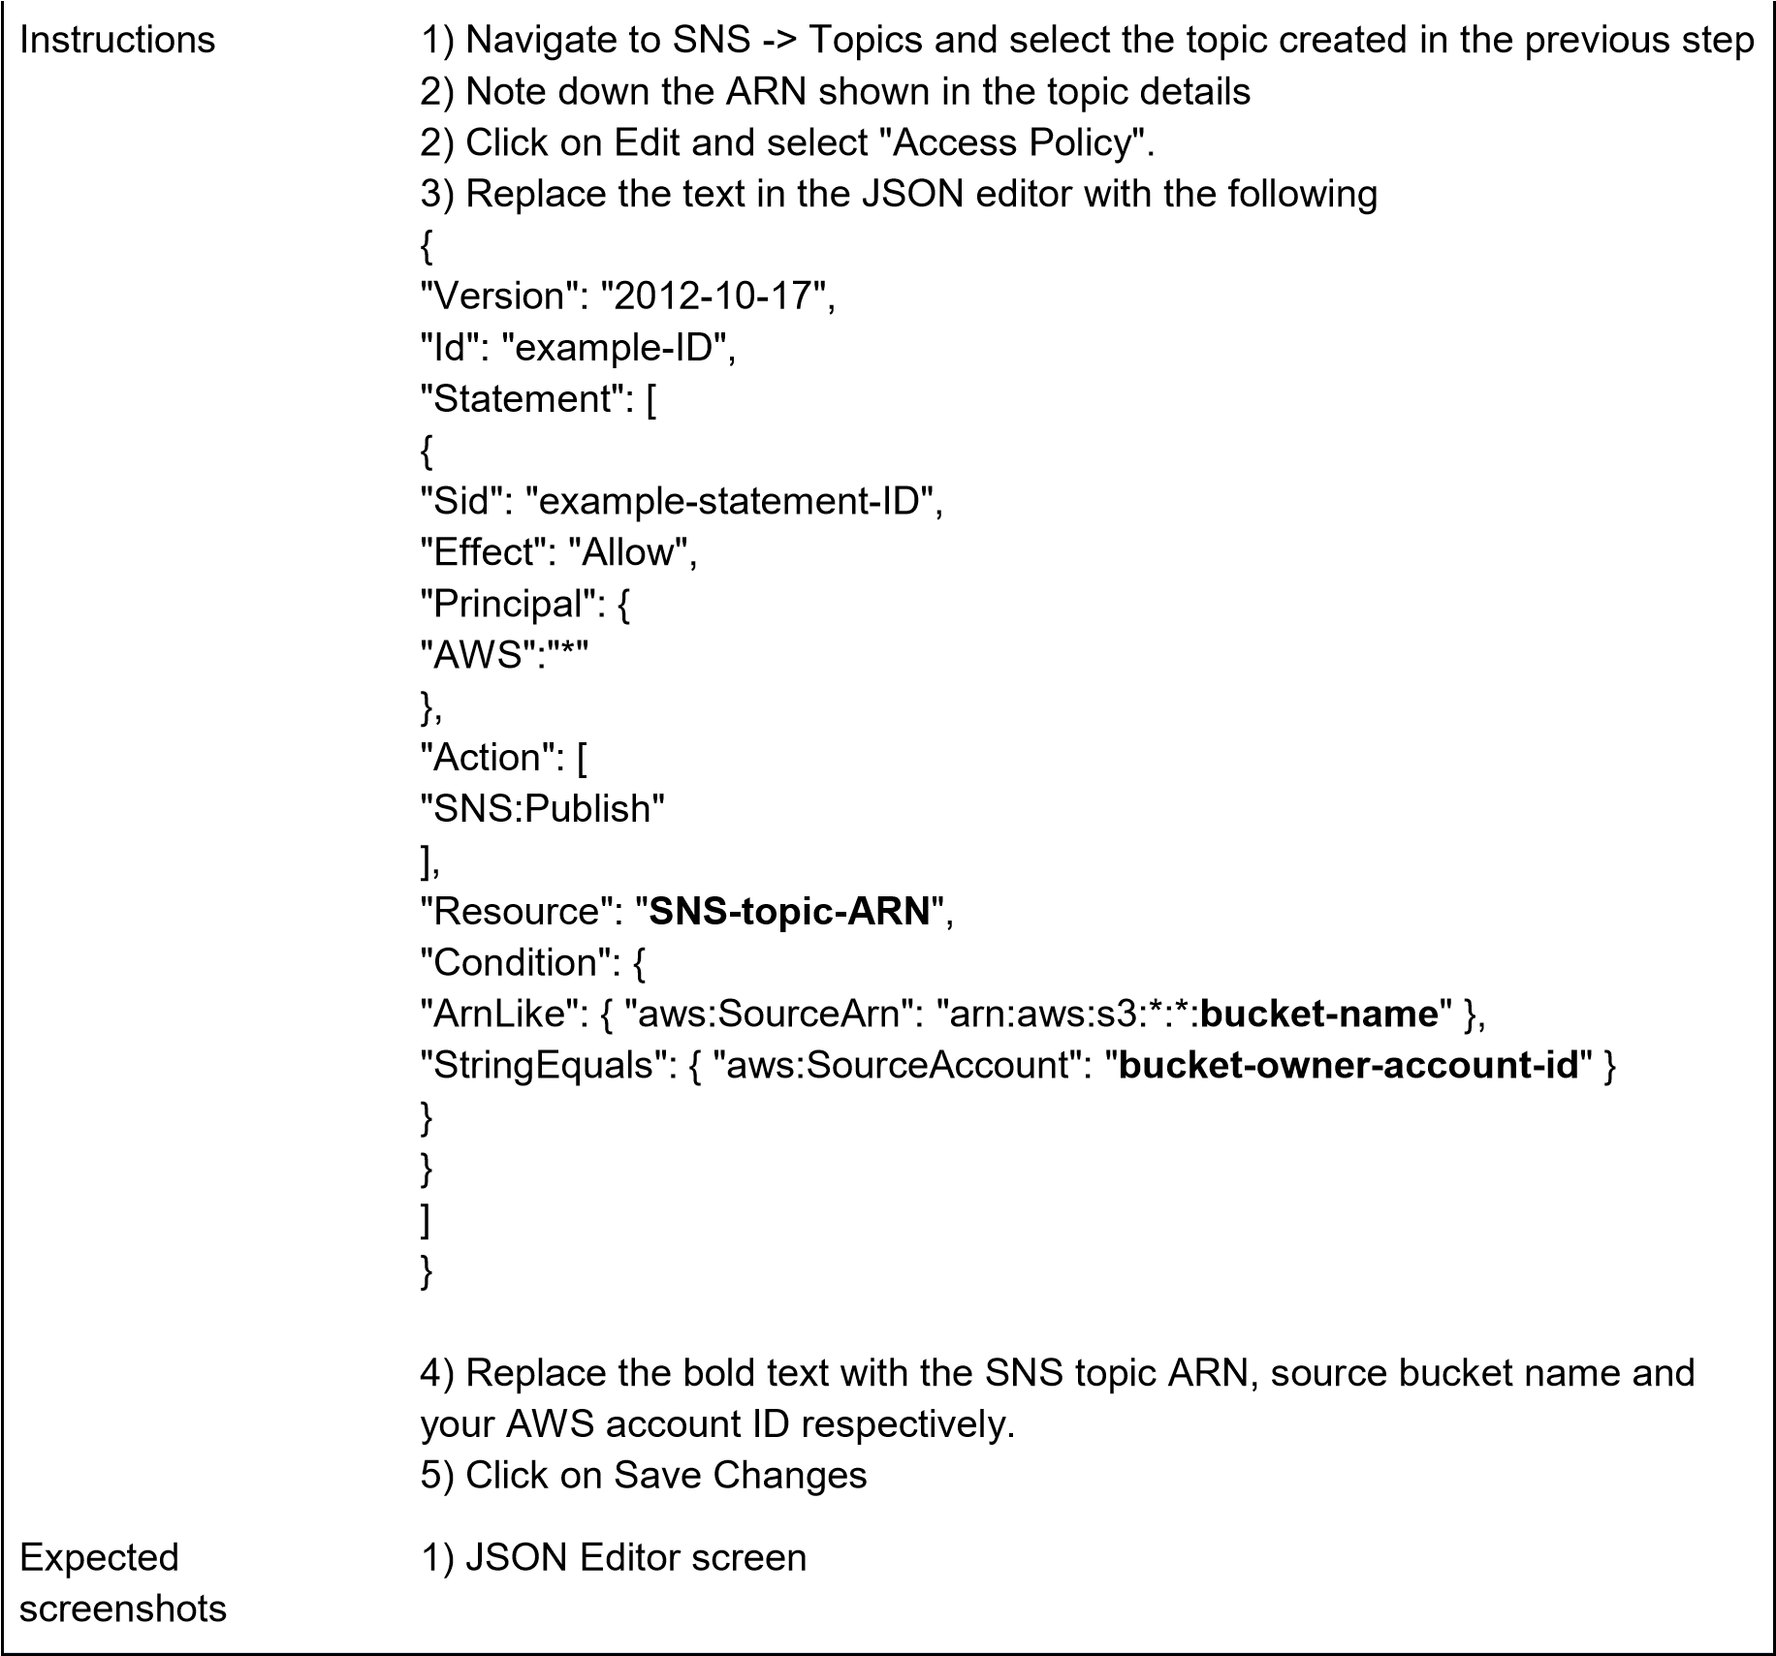

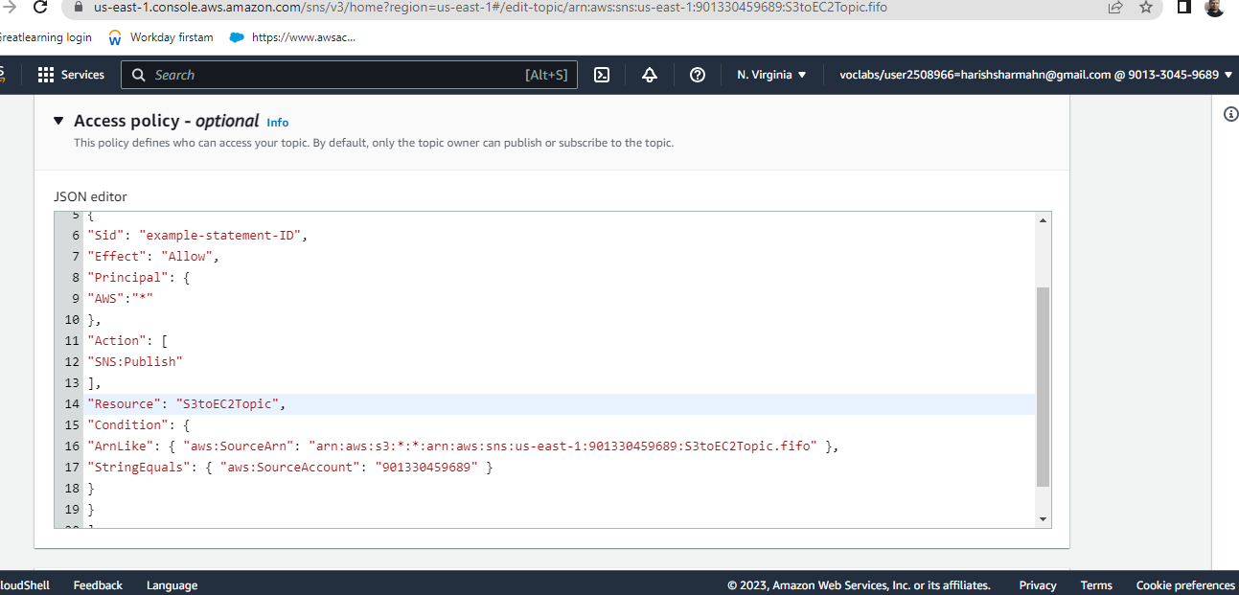

|  |  |
| --- | --- |
| Step number | d |
| Step name | Configuring SNS notifications for S3 |
| Instructions | 1. Navigate to S3 and select the source bucket created in Step 1 (a) 2. Select Properties and scroll down to Event Notifications and select it 3. Select "Create Event Notification" 4. Fillup the details as follows   Name : S3PutEvent  Select PUT from the list of radio buttons  Destination : Select SNS Topic  SNS : Select S3ToEC2Topic     1. Save Changes |
| Expected screenshots | 1) Event Configuration Screen |

**<Insert screenshot for d(1) here>** Step 2: Run the custom program in the EC2 instance

|  |
| --- |
| Step number a  Step name Creation of the EC2 instance and RDS instance  Instructions 1) Navigate to EC2 -> Instances   1. Create an EC2 instance with the following parameters   AMI : Amazon Linux 2  VPC : Default  Security group : Ports 22 and 8080 should be opened     1. Navigate to RDS 2. Create an RDS instance with the following parameters:     Engine type : MySql  Template : Dev/Test  Set the username and password as required  DB Instance class : Burstable  Instance type : t3.micro  Public Access : Yes  VPC Security group : Create New ()    Under Additional Configuration, add an initial database name. Take note of this name as it will be required later.    Uncheck “Enable Enhanced Monitoring”    Ensure that the security group created by the RDS deployment has port 3306 open for all incoming connections from all sources.  Expected 1) List of instances after creation of EC2 screenshots instance  2) List of RDS instances |

**<Insert screenshot for a(1) here>**

**<Insert screenshot for a(2) here>**

|  |  |
| --- | --- |
| Step number | b |
| Step name | Assignment of IAM role for EC2 instance |
| Instructions | 1. Navigate back to EC2- > Instances 2. Select the EC2 instance created in the previous step and select Actions-> Security -> Modify IAM role 3. Select the role LabInstanceProfile from the dropdown and click on Save |
| Expected screenshots | 1) Modify IAM role screen |

**<Insert screenshot for b(1) here>**

**<Insert screenshot for c(1) here>** 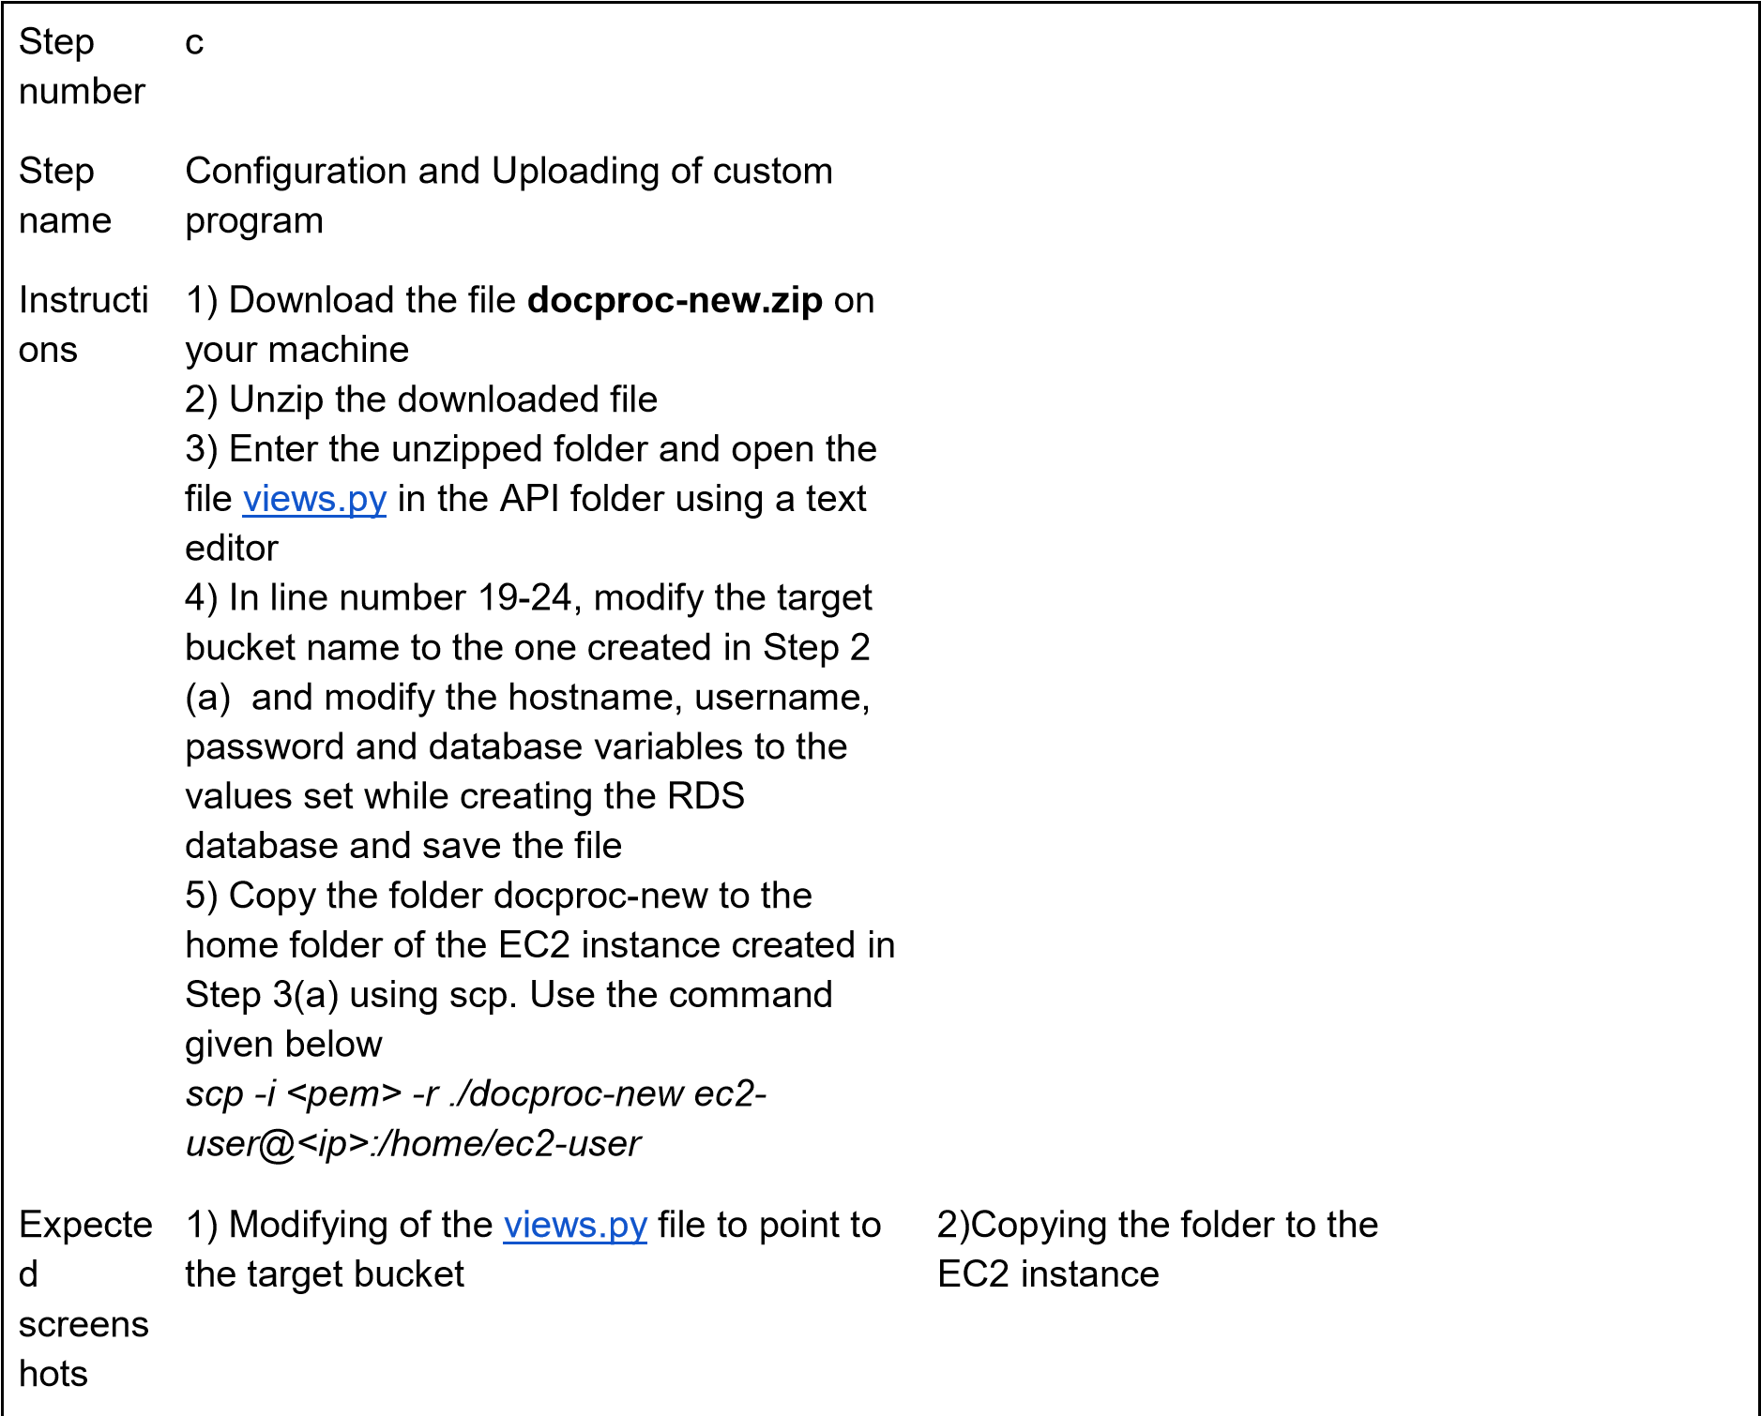

**<Insert screenshot for c(2) here>** Step 3: Creation and Verification of SNS subscription and Generation of CSV file

|  |  |
| --- | --- |
| Step number | a |
| Step name | Starting the  EC2 custom program |
| Instructions | 1. Log into the EC2 instance using SSH 2. Run the followng commands after successful SSH to start the server sudo cp -r docproc-new /opt sudo chown ec2-user:ec2-user -R /opt cd /opt/docproc-new sudo yum update   sudo yum install python-pip -y  python -m pip install --upgrade pip setuptools sudo pip install virtualenv virtualenv ~/.virtualenvs/djangodev source ~/.virtualenvs/djangodev/bin/activate pip install django pip install boto3  pip install mysql-connector-python-rf python manage.py runserver 0:8080    **Keep this terminal window open throughout the rest of the exercise** |
| Expected screenshots | 1) Server in  waiting state |

**<Insert screenshot for a(1) here>**

|  |  |
| --- | --- |
| Step number | b |
| Step name | Creation of  SNS  subscription |
| Instructions | 1. Navigate to SNS in the AWS Console and select the topic S3ToEC2Topic 2. Click on Create Subscription 3. Enter the following details   Protocol : HTTP  Endpoint : http://<host>:8080/sns where <host> in the public IP of the EC2 instance Click on Create Subscription   1. In the EC2 terminal window, look for the field "SubscribeURL" and copy the entire link given   **Note: If a message is seen "ValueError: No JSON object could be decoded", it can be safely ignored**   1. Paste that link into a browser window to verify the SNS subscription (Ignore any messages received in the web browser) |
| Expected screenshots | 1)  Subscription URL in EC2  terminal  Window |

**<Insert screenshot for b(1) here>**

|  |  |
| --- | --- |
| Step number | c |
| Step name | Generation of CSV file |
| Instructions | 1. Download the file **docproc-invoice.txt** provided with this workbook 2. Navigate to S3 in the AWS Console 3. Upload the sample invoice file to the source S3 bucket using the default options 4) Verify that a CSV file is generated in the target S3 bucket. This may take a few minutes   5) (Optional) Login to the RDS instance using your preferred MySQL client and check the table created inside the specified database. |
| Expected screenshots | 1) Generated CSV file in the target S3 bucket |

**<Insert screenshot c(1) here>**

**Answer the following questions**

Q1 Which of the following properties of an AWS resource is sufficient and necessary to uniquely identify it across all of AWS?

1. ARN
2. Region and ARN
3. ARN and Account number
4. Depends on the resource used

Enter

your

answer

here

Q2 Which of the following step numbers in Step 1 allowed S3 to publish to the SNS topic created?

1. 1(a)
2. 1(c)
3. 1(d)
4. 1(b)

Enter

your

answer

here

Q3 Which port is being used by SNS to send the notification to the custom program?

1. 8081
2. 80
3. 8080
4. 8065

Enter

your

answer

here

Q4 How many IAM roles can be attached to an EC2 instance at a time?

1. 2
2. 3
3. 1
4. Depends on the policies required Q5 As a product manager, how would you describe the benefits of this architecture to an client, as compared to an equivalent on-premises architecture?

Enter

your

answer

here

**Grades**

**distribution**

MCQs

6

(1.5

mark

each)

Subjective

questions

2

marks

Implementation

screenshots

12

marks

(1

marks

each)

Total

2

0

marks